Friends of Fairfax County Archaeology and Cultural Resources
Annual Meeting Agenda - November 15, 2025
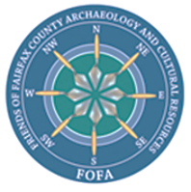
- Presidents Report

- Approval of Minutes from Last Annual Meeting

- Treasurer’s/ Membership Report

- FCPA-ACB Staff Report

- Elections – Slate of Officers:

- President – John Mullen
- VP – Sallie Lyons
- Treasurer – Lauren Bardwell
- Secretary – [Vacant]
- Director (and Website) – Alan Day
- Director – Vacant
- Director – Vacant

- Motion to elect Slate of Officers
- Motion to donate funds to the Fairfax County Park Authority Board, for use by the ACB
- Motion to close “official” part of the meeting and begin presentation from Dr. Stephen Potter !

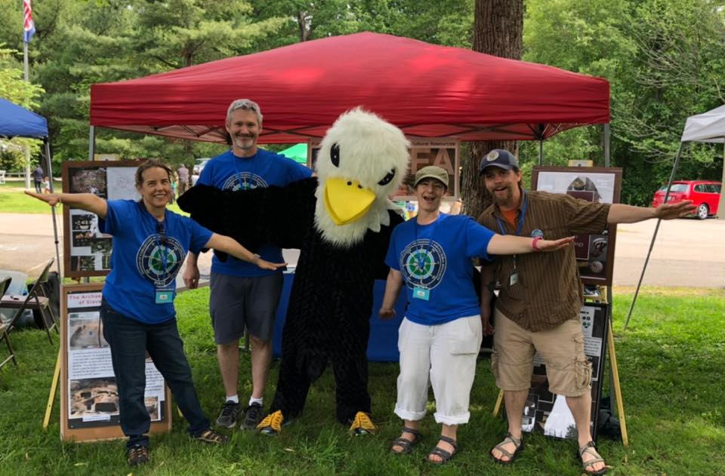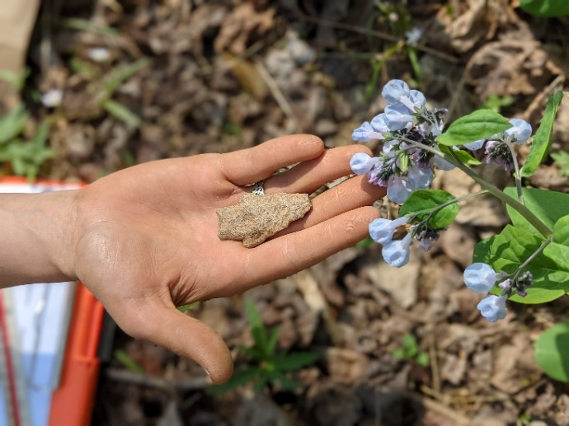
The Friends of Fairfax Archaeology and Cultural Resources (FOFA) is a 501c (3) non-profit organization that supports the Archaeology and Collections Branch of the Fairfax County Park Authority (FCPA). We seek to further promote the understanding and appreciation of Fairfax County's cultural resources through archaeology and historic preservation.

